Ex:1 | Private Cloud using OpenStack
24/6/2026 | Private Cloud using OpenStack

AIM
To install and configure OpenStack using DevStack on an Ubuntu virtual machine, verify the OpenStack services through the command line, create a test virtual machine using the CirrOS image, and access the OpenStack Horizon web dashboard.

OBJECTIVES
- Install the required packages and Git.
- Create and configure the OpenStack stack user.
- Download/configure DevStack and prepare local.conf.
- Verify hardware virtualization/KVM support.
- Run the DevStack installation successfully.
- Verify OpenStack services, compute services, agents, images, flavors and networks.
- Create and verify an OpenStack instance named test-vm.
- Access OpenStack Horizon through a web browser.

REQUIREMENTS
- Ubuntu 26.04 LTS virtual machine
- Oracle VM VirtualBox
- Internet connectivity
- Minimum 4 vCPUs recommended for the lab setup
- Sufficient RAM and disk space for DevStack
- Git

THEORY
OpenStack is an open-source cloud computing platform used to provide infrastructure services such as compute, networking, storage and image management. DevStack is a set of scripts used to install and configure a development-oriented OpenStack environment.
The major services used in this experiment include Keystone for identity, Nova for compute, Neutron for networking, Glance for image management and Cinder for block storage. Horizon provides a browser-based graphical interface for managing these services.

PROCEDURE

Step 1 – Verify Git installation
git --version

Step 2 – Create the stack user
sudo useradd -s /bin/bash -d /opt/stack -m stack
echo "stack ALL=(ALL) NOPASSWD: ALL" | sudo tee /etc/sudoers.d/stack sudo su - stack
id -un

Step 3 – Obtain DevStack
git clone https://opendev.org/openstack/devstack cd ~/devstack

Step 4 – Configure DevStack
nano local.conf cat local.conf

Step 5 – Verify virtualization support
egrep -c '(vmx|svm)' /proc/cpuinfo lsmod | grep kvm

Step 6 – Run DevStack
cd ~/devstack
./stack.sh

Step 7 – Load OpenStack credentials
source openrc admin

Step 8 – Verify OpenStack services
openstack service list openstack compute service list openstack network agent list

Step 9 – Verify images, flavors and networks
openstack image list openstack flavor list openstack network list

Step 10 – Verify/create the test instance
openstack server list openstack server show test-vm

Step 11 – Access the Horizon dashboard
Open Firefox/Chrome inside the Ubuntu VM. Browse to: http://127.0.0.1/dashboard/
Log in as admin using the configured password.

DevStack Configuration Used
[[local|localrc]] HOST_IP=10.0.2.15
GIT_BASE=https://opendev.org ADMIN_PASSWORD=secret DATABASE_PASSWORD=$ADMIN_PASSWORD RABBIT_PASSWORD=$ADMIN_PASSWORD SERVICE_PASSWORD=$ADMIN_PASSWORD
The above configuration was used during the successful DevStack deployment. The Horizon dashboard was later accessed locally through 127.0.0.1.

OBSERVATION

Verification | Observed Result | Status
Git | git version 2.53.0 | Verified
KVM | kvm_intel, kvm and irqbypass modules present | Verified
DevStack | stack.sh completed successfully | Successful
OpenStack services | Keystone, Placement, Glance, Nova, Neutron, Cinder and  legacy Nova listed | Verified
Compute services | Nova scheduler/conductor/compute services shown as enabled and  up | Verified
Image | cirros-0.6.3-x86_64-disk –  active | Verified
Instance | test-vm – ACTIVE | Verified
Instance network | private=10.0.0.55 | Verified
Horizon | OpenStack dashboard accessible at http://127.0.0.1/dashboard/ | Verified

OUTPUT
The following screenshots are included as practical evidence of the installation, configuration, verification and successful OpenStack operation.
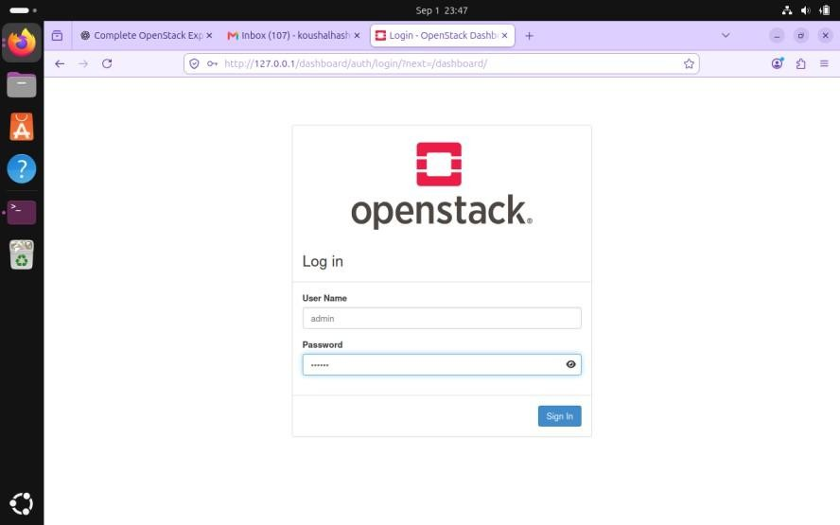
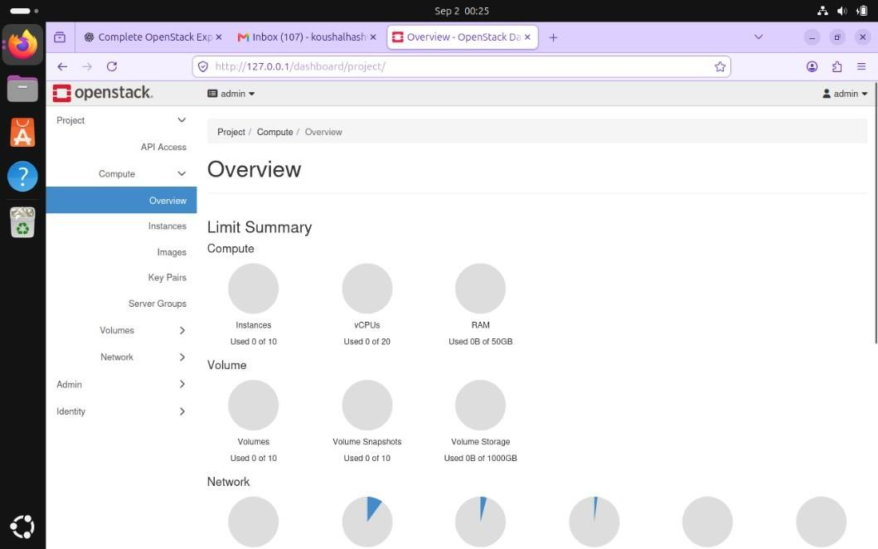

Figure : OpenStack Horizon web dashboard successfully opened in Firefox.

CONCLUSION
Thus, the basic installation, configuration and operation of an OpenStack cloud environment using DevStack were successfully completed.

